##### 

IoT based water quality assistant for Irrigation

**Capstone Project Report MID SEMESTER EVALUATION**

## Submitted by:

### (101983045)PRAKHAR SRIVASTAVA (101983044)SURYANSH BHARDWAJ (101983043)UMANG SHARMA

### BE Third Year, CoE

## CPG No: 101

Under the Mentorship of Dr. Karun Verma Assistant Professor



#### Computer Science and Engineering Department Thapar Institute of Engineering and Technology, Patiala

#### JULY 2021

# ABSTRACT

The project develops a system to help determine whether the water quality is fit for irrigation purpose or not. The sensors collect data about the water such as its turbidity, PH value etc. which is then transmitted to a microcontroller where it is analyzed using machine learning models that whether the water needs to be treated or not.

Our idea is to make use of various electrical components to help the farmers determine whether the water they are about to use would help their crops or not. Along with this the data collected will be uploaded on an online portal where through data visualization the user can understand the data in a clearer manner.

The project will make use of IoT (Internet of Things) which means that we use microcontroller, LORA modules and various sensors to collect data regarding water and transmit it to analyze it in order to provide a real world solution.

The data analyzed will determine whether the water needs to be sent to a treatment facility or to the fields for irrigation. In this way the proposed solution will help the farmers save on losses due to bad quality water ruining their crops.

The project involves use of various concepts such as machine learning (regression analysis) for determining water quality. Along with that in order to complete the project Arduino programming and web development concepts will be applied. The whole project will be given a proper structure by applying the concepts learned in Software Engineering.

In this way our team aims to provide a reliable and efficient solution which would be helpful to a number of people and contribute towards the agriculture segment of our country.

# DECLARATION

We hereby declare that the design principles and working prototype model of the project entitled

IoT based water quality assistant for Irrigation is an authentic record of our own work carried out in the Computer Science and Engineering Department, TIET, Patiala, under the guidance of Dr. Karun Verma during 6th semester (2021).

Date:

|  |  |  |
| --- | --- | --- |
| **Roll No.** | **Name** | **Signature** |
| 101983045 | Prakhar Srivastava |  |
| 101983044 | Suryansh Bhardwaj |  |
| 101983043 | Umang Sharma |  |

*Counter Signed By:*

Faculty Mentor:

Dr.

Designation

CSED,

TIET, Patiala

**ACKNOWLEDGEMENT**

We would like to express our thanks to our mentor Dr. Karun VermaMentor. He has been of great help in our venture, and an indispensable resource of technical knowledge. He is truly an amazing mentor to have.

We are also thankful to Dr. Maninder Singh, Head, Computer Science and Engineering Department, entire faculty and staff of Computer Science and Engineering Department, and also our friends who devoted their valuable time and helped us in all possible ways towards successful completion of this project. We thank all those who have contributed either directly or indirectly towards this project.

Lastly, we would also like to thank our families for their unyielding love and encouragement. They always wanted the best for us and we admire their determination and sacrifice.

Date:

|  |  |  |
| --- | --- | --- |
| **Roll No.** | **Name** | **Signature** |
| 101983045 | Prakhar Srivastava |  |
| 101983043 | Umang Sharma |  |
| 101983044 | Suryansh Bhardwaj |  |

**TABLE OF CONTENTS**

ABSTRACT… ii

DECLARATION… iii

ACKNOWLEDGEMENT… iv

LIST OF TABLES vii

LIST OF FIGURES viii

LIST OF ABBREVIATIONS ix

##### CH APTER… Page No.

|  |  |  |  |
| --- | --- | --- | --- |
| **1.** | **Introduction** | | **1** |
|  | 1.1 | Project Overview |  |
|  | 1.2 | Need Analysis | |
|  | 1.3 | Research Gaps | |
|  | 1.4 | Problem Definition and Scope |  |
|  | 1.5 | Assumptions and Constraints |  |
|  | 1.6 | Standards |  |
|  | 1.7 | Approved Objectives |  |
|  | 1.8 | Methodology |  |
|  | 1.9 | Project Outcomes and Deliverables |  |

1.10 Novelty of Work

##### Requirement Analysis 8

* 1. Literature Survey
     1. Theory Associated With Problem Area
     2. Existing Systems and Solutions
     3. Research Findings for Existing Literature
     4. Problem Identified
     5. Survey of Tools and Technologies Used
  2. Software Requirement Specification
     1. Introduction
        1. Purpose
        2. Intended Audience and Reading Suggestions
        3. Project Scope
     2. Overall Description
        1. Product Perspective
        2. Product Features
     3. External Interface Requirements
        1. User Interfaces

v

* + - 1. Hardware Interfaces
      2. Software Interfaces
    1. Other Non-functional Requirements
       1. Performance Requirements
       2. Safety Requirements
       3. Security Requirements
  1. Cost Analysis
  2. Risk Analysis

##### Methodology Adopted 19

* 1. Investigative Techniques
  2. Proposed Solution
  3. Work Breakdown Structure
  4. Tools and Technology

1. **Design Specifications 27**
   1. System Architecture
   2. Design Level Diagrams
   3. User Interface Diagrams
   4. Snapshots of Working Prototype

##### Conclusions and Future Scope 35

* 1. Work Accomplished
  2. Conclusions
  3. Environmental (/ Economic/ Social) Benefits
  4. Future Work Plan **APPENDIX A: References APPENDIX B: Plagiarism Report**

**LIST OF TABLES**

|  |  |  |
| --- | --- | --- |
| **Table No.** | **Caption** | **Page No.** |
| Table 1 | Research Gap | 2 |
| Table 2 | Sample Assumptions | 4 |
| Table 3 | Sample Constraints | 4 |
| Table 4 | Research Findings for Existing Literature Survey | 10 |
| Table 5 | COST BREAKUP | 19 |
| Table 6 | Investigative Techniques | 19 |
| Table 7 | Tools and Technology | 25 |

# LIST OF FIGURES

|  |  |  |
| --- | --- | --- |
| **Figure No.** | **Caption** | **Page No.** |
| Figure 1 | Block Diagram of Architecture | 6 |
| Figure 2 | Landing Page of web portal | 15 |
| Figure 3 | Interface demonstrating login/registration page of web portal | 15 |
| Figure 4 | Interface demonstrating visualization page of the web portal | 16 |
| Figure 5 | Interface demonstrating the analysis page of the web portal | 16 |
| Figure 6 | Arduino IDE interface, will be used for monitoring data stream and uploading code to microprocessor | 17 |
| Figure 7 | Google firebase used for managing data and uploading data to web portal | 18 |
| Figure 8 | Work Breakdown Structure | 24 |
| Figure 9 | Gantt Chart | 25 |
| Figure 10 | MVC architecture-Django | 27 |
| Figure 11 | Class Diagram | 28 |
| Figure 12 | ER Diagram | 28 |
| Figure 13 | DFD level 0 | 29 |
| Figure 14 | DFD Level 1 | 29 |
| Figure 15 | DFD Level 2 | 30 |
| Figure 16 | Landing Page of Web Portal | 30 |
| Figure 17 | Interface demonstrating the analysis page of the web portal | 31 |
| Figure 18 | Interface demonstrating visualization page of the web portal | 31 |
| Figure 19 | Landing Page | 32 |
| Figure 20 | Wireframe Page | 32 |
| Figure 21 | post login webpage | 33 |
| Figure 22 | Sensor data Graph Page | 33 |
| Figure 23 | Microcontroller | 34 |

# LIST OF ABBREVIATIONS

|  |  |
| --- | --- |
| LoRa | Long Range |
| SAR | Specific Absorption Rate |
| LoRaWAN | LoRa Wide Area Networks protocol |

# INTRODUCTION

#### Project Overview

Water quality illustrates the condition of the water, including its chemical, physical, and biological characteristics, usually with respect to its suitability for a particular purpose such as drinking, irrigation or swimming. The composition of water is dependent on various natural factors (geological, topographical, meteorological, hydrological and biological) and varies with seasonal differences, weather conditions and water levels. The quality of ground water used for irrigation, thus, varies with respect to geographical location, time of the year as well as weather conditions. This variation can result in unsuitable water, and consequently a lower yield for many crops.

According to paper on ‘Water Quality for Agriculture’ published by the Food and Agriculture Organization of the United Nations, water used for irrigation can vary greatly in quality depending upon type and quantity of dissolved salts [1]. The suitability of water for irrigation is determined by the total amount of salt present as well as by the kind of salt. Various soil and cropping problems may develop if the total salt content increases, and special management practices may be required to maintain acceptable crop yields.

The Project focuses on determining quality of water and classifying water as good quality or bad quality for the purpose of irrigation as well as automatically diverting bad-quality water to the treatment pump, before going to fields.

It is divided into three major segments:

**A. Data Collection**

Data related to the temperature, turbidity, Potential of Hydrogen (pH), and most importantly the Sodium Absorption Ratio (SAR) of the water will be collected by the Team [2,3]. This raw data will then be used to determine the water quality by using a model uploaded onto the Microcontroller.

**B. Treatment of Water**

Using the raw data collected in Segment A, a machine learning model uploaded onto the microcontroller will then determine whether the water quality is suitable for irrigation or not. Based on the quality of water, so determined, the Project will turn on the appropriate water pump, i.e., treatment pump (in case of bad-quality water) or field water pump (in case of good-quality water).

**C. Data Analysis and Visualization**

The raw data will also be uploaded onto an online dashboard where it will be visualized and analysed on a long-term basis. This phase is an ‘add on’, in order to keep the local apparatus independent from the remote website.

#### Need Analysis

In present day water quality in general and microbial drinking and process water quality in particular, is monitored either through time consuming laboratory methods or various costly online sensors having low sensitivity. Water quality monitoring results are thus either delayed or insufficient to support proactive management action.

Our project aims to develop a monitoring system which aims to provide reliable sensors, an established IoT network to monitor water quality and a real time dashboard to analyse data and classify water as fit or unfit [4]. The monitoring system established by our project will be scalable and cost effective which will resolve the issue of non- scalable and costly monitoring methods.

Irrigation water quality is a critical aspect of crop production. There are many factors which determine water quality. Among the most important are alkalinity, pH and soluble salts. Poor quality of water is generally responsible for slow growth of the crop, poor aesthetic quality of the crop and, in some cases, can result in the gradual death of the plants. Poor water of quality leads to major losses for farmers and can also affect soil health.

Our project apart from making a monitoring system to determine the presence of unwanted elements in water will include an automated segregation element which will direct poor-quality water into treatment plant and the treated good-quality water into the field. Hence, the project will stop the poor-quality water from entering the fields, channelise it to treatment plant for making available good-quality water for the fields. The whole system developed will be automated, thereby facilitating not-so-technical savvy farmers to operate it with ease.

Water monitoring nano sensors have an increasing market to the extent that these nano sensors have a share of about 30% of the whole nano sensors market. In general, there is growing potential for investment in manufacturing of water monitoring nano sensors, and they will prove to be attractive investment for companies in future.

Since our project includes water monitoring sensors and a cost-effective IoT network, this stands in parallel to the technologies being developed by many start-ups and hence, is very much in demand.

#### Research Gaps

#### TABLE 1: Research Gap

|  |  |  |
| --- | --- | --- |
| Research Gaps | Deficiencies in Research | References |
| Usage of LORA for communication and digital data transmission | LORA module is not commonly used for digital data transmission and other wired modes of transmission are preferred | Wang et al, Xinglin Bay in Xiamen, China [5]. |
| Selection of classification methods for water analysis | The algorithms generally considered are Support Vector Machine (SVM), k Nearest Neighbour (kNN), single-layer neural network and Deep neural network which are computationally expensive for a project for our scale | Shafi et al. investigated the ofsurface water across 11 locations in Pakistan [6]. |
| Speed and efficiency | The sensors take time to gather data which can be sent to microcontroller for training making real time calculation a bit delayed |  |
| Lack of onsite analysis | Generally data gathered is transferred to a different system for analysis whereas our solution aims to provide the analysis onsite making use of the sensors and microcontroller on the ground itself |  |
| Cost Structure | The current research projects are funded by city corporations or private firms which makes the research findings expensive for our project | K. Saravanan, E. Anusuya, R. Kumar, Real-time water quality monitoring using Internet of Things in SCADA. Environ. Monit. Assess. 190(9), 556 (2018).[7] |
|  |  |  |

#### 

#### Problem Definition and Scope

#### Problem:

#### The suitability of water for irrigation is determined by the total amount and type of salts present.

#### Soil and cropping problems develop if the total salt content increases which can lead to heavy losses for the farmers. If unfit water is used it will destroy the crops harvested for the season and will affect the agricultural production of the country by changing the overall yield of the crops.

#### The unfit water if detected earlier could easily be used after sending it to a treatment facility and this would ensure minimum wastage of water.

#### Scope:

#### Agriculture and its allied industries account for almost 15% contribution to the GDP of India and employs around 40% of the Indian workforce in some form.

#### In this way the farming sector is a billion dollar industry with a large number of farmers still dependent on fresh water for their crops. The water is derived from one of the natural sources such as rivers, and would often require treatment to ensure good quality water is used by the farmers on for their crops. In this our solution can be of huge help to these farmers to provide them with a constant flow of suitable irrigation water and to reduce their dependency on artificial fertilizers in order to ensure their yield

##### 1.5 ASSUMPTIONS AND CONSTRAINTS

##### 

##### Table 2: Sample Assumptions

|  |  |  |
| --- | --- | --- |
| **S. No.** | | **Sample Assumptions** |
| **1** | | The solution proposed by our team uses sensors and machine learning models to calculate the water quality for redirection of water to treatment facility if the water is unfit for irrigation and displays the data analysis and visualization on an online dashboard which can be accessed by the farmer.  Therefore in order for the farmer to fully utilize our team’s solution it is **assumed that the location has internet access.** |
| **2** | | In order for the water quality to be calculated properly it is important that the sensors are properly placed. The sensors communicate with the microcontroller via the LORA receiver. Therefore it is assumed that there are no obstacles between the transmitters and receivers. In case of an obstacle the data may not be gathered properly which can lead to errors | |
| **3** | | The main motive of our solution is to redirect water to either a treatment facility or to a field depending on the water quality. The data regarding water quality is analysed and then the microcontroller activates either of the two pumps depending on the water quality. Therefore assumption is taken that both the pumps are functioning well and that each pump will correctly redirect water towards the required destination | |

|  |  |
| --- | --- |
| **S. No.** | **Sample Constraints** |
| **1** | The data transmission rate of LORA modules is low due to which the data transmission to microcontroller via the LORA modules may take some time making the entire process of water quality detection a bit time taking. |
| **2** | The online dashboard designed by our team primarily serves the purpose of presenting the data analyzed in a visual manner. The farmer can see the data recorded about the water quality which might be useful for him. Therefore it is important that the data is collected and uploaded onto the dashboard regularly for the dashboard to function properly. The farmer must ensure that the sensors work regularly to gather new data which can then be updated on the dashboard. |

**Table 3: Sample Constraints**

#### STANDARDS

#### IEEE 802.11 is part of the IEEE 802 set of local area network (LAN) technical standards, and specifies the set of media access control (MAC) and physical layer (PHY) protocols for implementing wireless local area network (WLAN) computer communication. They are the world's most widely used wireless computer networking standards. IEEE 802.11 is used in most home and office networks to allow laptops, printers, smartphones, and other devices to communicate with each other and access the Internet without connecting wires

#### Approved Objectives

* To integrate different sensors and Wi-Fi module with an IoT device and build a cost-effective hardware setup [8].
* To process data from different sensors like SAR sensor, pH sensor humidity sensor etc. calibrate the readings and send it to web portal using the IoT device.
* To develop an interactive web dashboard to tabulate live readings from the sensors for the user.
* To perform analysis of data gathered from different sensors to determine quality of water and to classify water as good quality or bad quality and to generate a corresponding signal to IoT device to turn on the appropriate water pump, *i.e.,* treatment pump (in case of bad-quality water) or field water pump (in case of good-quality water).

#### Methodology

#### As discussed in the Project Overview, the project will be divided into three segments or phases.

#### Initially the field component will collect the temperature, pH value, turbidity and flow of water.

#### Moreover, it will also be collecting data on the SAR value of the water.

#### 

#### The SAR value will be specifically calibrated in conjunction with the Electronics (ECE) and Chemistry (CHE) departments of TIET, wherein the ECE department will be helping in the creation of the sensor, while the CHE department will be helping to analysis samples of water to calibrate the sensor.

#### This data will be collected by the sensors being connected to transmitting LORA modules which transmit data wirelessly through a WAN network, with a receiver connected to a microcontroller.

#### Moving onto the next phase, this data will be analysed with the help of a Machine Learning model uploaded directly onto the Microcontroller.

#### Using this analysis, the water can be directed to a treatment facility if it is unsuitable for irrigation, or any other intended use.

#### The data will also be uploaded online in the next phase and this data will be accessible by other Users online.

*Figure 1: Block Diagram of architecture*

As can be seen, Figure 1 is showing the simple block diagram of the project architecture. The sensors will communicate with the Microcontroller via the LORAWAN which will activate either Pump 1 or Pump 2 depending on the water quality and all the data will be sent to the online Dashboard [9].

#### Project Outcomes and Deliverables

#### Using concepts of machine learning, data regarding the quality of given water would be collected.

#### A working online dashboard would be designed where the data can be uploaded and accessed by the user as and when required

#### The capstone project is intended to help determine if the water quality is good enough to be used for irrigation, thus, leading to increase in yield of crops quantitatively as well as qualitatively.

#### Novelty of Work

#### The proposed solution is unique since there are no direct competitors in the market which are exactly identical to our product. Our product involves the use of IoT to help an underdeveloped sector like agriculture and help the farmers.

#### The solution also provides an online dashboard which helps the user keep track about the data regarding the water quality so that they can understand the quality of water they are using.

#### In this way providing on online dashboard to the users makes our solution unique.

#### Our solution is feasible, cost-effective and easy to understand and therefore can be used widely.

**2. Requirement Analysis**

**2.1 Literature Survey**

**2.1.1 Theory Associated With Problem Area**

In order to calculate water quality, the indices generally used for the same were investigated.

Indices used in water quality.

**1.** **Chemical oxygen demand (COD):** This is the equivalent amount of oxygen consumed (measured in mg/l) in the chemical oxidation of all organic and oxidisable inorganic matter contained in a water sample.

**2.** **Biochemical oxygen demand (BOD):** This is the oxygen requirement of all the organic content in water during the stabilisation of organic matter usually over a 3 or 5 day.

**3.** **pH**: This is the measure of the acidity or alkalinity of water. It is neutral (at 7) for clean water and ranges from 1 to 14.

**4.** **Dissolved oxygen (DO):** This is the amount of oxygen dissolved in a water sample (measured in mg/l).

**5.** **Turbidity:** This is the scattering of light in water caused by the presence of suspended solids. It can also be referred to as the extent of cloudiness in water measured in nephelometric turbidity units (NTU).

**6.** **Electrical conductivity (EC):** This is the amount of electricity that can flow through water (measured in Siemens), and it is used to determine the extent of soluble salts in the water. 248 J. O. Ighalo et al.

**7.** **Temperature:** The is the degree of hotness or coldness of the water and usually measured in degrees Celsius (°C) or Kelvin (K).

**8.** **Oxidation-reduction potential (ORP):** This is the potential required to transfer electrons from the oxidant to the reductant, and it is used as a qualitative measure of the state of oxidation in water.

**9.** **Salinity:** This is the salt content of the water (measured in parts per million).

**10.** **Total Nitrogen (TN):** This is the total amount of nitrogen in the water (in mg/l) and is a measure of its potential to sustain and eutrophication or algal bloom.

**11.** **Total phosphorus (TP):** This is the total amount of phosphorus in the water (in mg/l) and is a measure of its potential to sustain and eutrophication or algal bloom

**2.1.2 Existing Systems and Solutions**

Similar to the theory above, two main water analyzer products were explored.

**1. SWA1** – Smart Water Analyzer, a highly sensitive, affordable spectrum sensor for continuous online monitoring and rapid detection of microbial contamination in water.

The water from the water source pipe is passed into the SWA-1 sensor, and flows through the sensor’s inner channel. Two LED sources are installed at one end of the channel and emit light at various wavelengths, 260-300 nm and 750-900 nm respectively. A special sensitive receiver is installed at the opposite end of the channel. Emitted light beams pass through the water medium in the channel and encounter particles of various origin. As a result, light energy is absorbed by the particles, and the receiver identifies reduction in the energy power, as compared to that measured when the “baseline” water quality reference was established (which may be referred to as a “reference light energy” level).

to obtain reliable data on the microbial contamination load in water, an additional LED source is used in the sensor’s channel that emits light at wavelengths in the range of 750-900 nm. Under such radiation wavelengths, light energy is absorbed by particles of non-biological origin. SWA-1 compares measurement results at various light wavelength ranges, and if certain ratios between signal strength levels at various UV and IR wavelengths are reached, the sensor provides an indication whether the contamination is microbiological or general.

The SWA1 sensor sensitivity starts at 10 bacteria in 1 milliliter of source water. Such high sensitivity is attained by a proprietary algorithm of the water source irradiation by light sources. The unique light radiation algorithm and self-cleaning ability  constitute the principal IP claimed in Fluidsens patent applications.

**2. VWM Solutions**

ColiMinder technology is based on direct measurement of specific metabolic (enzymatic) activity of target organisms present in the sample. The enzymatic approach directly measures the specific enzymatic activity present in the sample. The measured enzymatic activity per sample volume is used as a measure of the contamination.

The enzymatic measurement approach is the only rapid measurement approach that allows:

->Technology independent determination if contamination limits

->Calibration of devices independent of their measurement technology

The enzymatic approach evaluates the level of contamination by measuring a signal from all target organisms in the sample volume. This approach requires no sample pre-treatment and less sophisticated technology and is therefore more robust than approaches evaluating individual organisms.

There are enzymes that are specific to certain organisms or groups of organisms. This offers the possibility to specifically measure the metabolic activity of the respective target organisms.The most basic indication of a viable organism is its metabolism, since it reflects the energy that the cell takes from the environment. This metabolism takes place through enzymes.The metric is the enzymatic activity per volume of a specific enzyme. It reflects the energetic turnover of the target organisms per volume or in other words the concentration of living target organisms, which represents the degree of contamination.

KEY FEATURES:

->fully automated sampling, measurement, cleaning and calibration

->Online data visualization and automatic notification

->1000 measurements without staff intervention

->up to 54 (80 in special cases) measurements per day

->Fully controllable through internet connection

->2 sample intakes (more optional)

DATA TRANSFER AND VISUALIZATION:

->Measurements data is directly transmitted to server through internet/ network connection

->Live data visualization on dedicated website, results can be downloaded

->Automatic notifications can be set (E-mail, SMS)

->Measurement results are also available through RS232/RS485 or Modbus TCP (optional)

->Measurement results can be saved on USB Flash Drive directly from the device

->4 to 20 mA output optional

**2.1.3 Research Findings for Existing Literature**

Table 4: Research Findings for Existing Literature Survey

|  |  |  |  |  |  |  |
| --- | --- | --- | --- | --- | --- | --- |
| **S.** | **Roll no.** | **Name** | **Paper Title** | **Tools/** | **Findings** | **Citation** |
| **No.** | NR |  | **Technology** |
| 1 | 101983043 | Umang Sharma | Surface Water Pollution Detection using Internet of Things,  Shafi et al. | Investigated the surface water across 11 locations in Pakistan by  monitoring pH, turbidity and temperature. The algorithms considered were Support Vector Machine (SVM), k Nearest Neighbour (kNN), single-layer neural network and deep neural network. | It was observed from the learning process on the 667 lines of data that deep neural network had the highest accuracy (at about 93%). The model could accurately predict water quality in the future six months. | Shafi, Uferah & Mumtaz, Rafia & Anwar, Hirra & Qamar, Ali & Khurshid, Hamza. (2018). Surface Water Pollution Detection using Internet of Things. 92-96. 10.1109/HONET.2018.8551341.[6] |
| 2 | 101983043 | Umang Sharma | Application of Environmental Internet of Things on water quality management of urban scenic river,  Wang et al | Chemical analysis of water was done by monitoring COD, pH, Turbidity, Temperature, Salinity, ORP.  COD was measured by a Hach analyzer DR5000.  The concentrations of NH4+-N, NO2−N,NO3−N, total phosphorus (TP), and total nitrogen (TN)were measured according to the standard method (MEPC2002b) | Their system was divided into three subsystems-  Data acquisition, Digital data and Data processing | Wang, Shumei & Zhang, Zhaoji & Ye, Zhi-Long & Wang, Xiaojun & Lin, Xiangyu & Chen, Shaohua. (2013). Application of Environmental Internet of Things on water quality management of urban scenic river. The International Journal of Sustainable Development and World Ecology. 20. 10.1080/13504509.2013.785040.[5] |
| 3 | 101983045 | Prakhar Srivastava | Real-time water quality monitoring using Internet of Things in SCADA,  Saravanan et al | Monitored the turbidity, temperature and colour using technology that was usable in real-time and employed a GSM module for wireless data transfer | Proposed a new SCADA system that integrates with the IoT technology for real-time water quality monitoring. Physical parameter such as temperature, turbidity, and color were added to the system. This real-time application generates, collects, transfers, and stores sensor data in the web server by using the GSM module. | Saravanan, K., Anusuya, E., Kumar, R. et al. Real-time water quality monitoring using Internet of Things in SCADA. Environ Monit Assess 190, 556 (2018). https://doi.org/10.1007/s10661-018-6914-x[7] |
| 4 | 101983045 | Prakhar Srivastava | Analysis and prediction of water quality using LSTM deep neural networks in IoT environment | Temperature, pH, DO, Conductivity, Turbidity, COD and NH3 were monitored using IoT enabled devices which incorporated a Long Short-Term Memory (LSTM) deep learning neural network. | The results of the study indicate that the predicted values of the model and the actual values were in good agreement and accurately revealed the future developing trend of water quality, showing the feasibility and effectiveness of using LSTM deep neural networks to predict the quality of drinking water. | Liu, P. & Wang, J. & Sangaiah, A.K. & Xie, Y. & Yin, X.. (2019). Analysis and prediction of water quality using LSTM deep neural networks in IoT environment. Sustainability (Switzerland). 11. 10.3390/su1102058.[10] |
| 5 | 101983044 | Suryansh Bhardwaj | Real-time water quality system in internet of things,  Zin et al. | pH, turbidity, temperature, water level and carbon dioxide monitored using wireless sensor network enabled by IoT  system consisting of Zigbee wireless communication protocol, Field Programmable Gate Array (FPGA) and a personal computer. | The results of the proposed system were validated with the laboratory  experiments. Based on the results, it can be concluded that there was no significant difference  of water data measurement between the proposed system and the laboratory measurement. The  proposed WQM system was able to minimise the operating time, cost and power consumption | M Cho Zin et al 2019 IOP Conf. Ser.: Mater. Sci. Eng. 495 012021 |
| 6 | 101983044 | Suryansh Bhardwaj | GIS-based assessment of groundwater quality for drinking and irrigation purposes in central Iraq | The analysed water quality parameters were used as an attribute database to produce thematic maps using a geographical information system (GIS) environment.  the water quality index (WQI) and the irrigation water quality index (IWQI) were calculated for different groundwater samples using various parameters including the Electrical Conductivity (EC), Cl−, HCO3−, Na+ and pH. Moreover, the groundwater suitability for irrigation purposes has been assessed using indices such as Kelly’s ratio (KR), sodium absorption ratio (SAR), residual sodium carbonate (RSC), soluble sodium percentage (SSP) and permeability index (PI). | The SAR ratio obtained from the samples indicates a medium to high sodium concentration, which is appropriate for irrigation but not ideal. Also, SSP values showed that 30% of the water samples tested are not safe for irrigation. Meanwhile, the permeability index (PI) results showed that water quality in the study area is appropriate for irrigation use. | Makki, Z.F., Zuhaira, A.A., Al-Jubouri, S.M. *et al.* GIS-based assessment of groundwater quality for drinking and irrigation purposes in central Iraq. *Environ Monit Assess* **193,**107 (2021). https://doi.org/10.1007/s10661-021-08858-w[11] |
|  |  |  |  |  |  |  |

**2.1.4 Problem Identified**

The biggest issue that was seen whilst exploring previous methods of water quality assessments was that the data collection and data analysis for assessing the water quality were not being done in an automated manner. Whilst some used machine learning methods such as SVM, kNN to classify water, it was not being done on-site. In most cases the data was being collected, uploaded to a computer for analysis using computationally expensive machine learning algorithms like the ones mentioned above. This will be detrimental to a farmer who may not have 24/7 access to the internet.

This brings us to the second point that there has not been enough research regarding simpler classification techniques. K nearest neighbours requires constant calculation and sorting. Deep learning neural networks require a lot of memory based on the transformers used. We believe that carefully selected features along with using a simpler classification technique will work just as well, if not better than the ones already being used.

2.1.5 Survey of Tools and Technologies Used

The following tools/technologies were observed during the literature survey

* **Machine Learning**: Machine learning is an application of artificial intelligence (AI) that provides systems the ability to automatically learn and improve from experience without being explicitly programmed. **Machine learning focuses on the development of computer programs** that can access data and use it to learn for themselves.
* **Sensors (IoT)**: A sensor can refer to **any piece of hardware that translates physical activity into real-time digital data for processing**, and they are found in nearly every IoT device. Sensors allow IoT devices to monitor and gather data on their own without user intervention, making our lives easier.
* **Wireless Communication Devices**: Wireless communication devices are **a type of data communication devices that deliver data wirelessly delivered wirelessly**. It includes all procedures and forms of connecting and communicating between two or more devices using a wireless signal through wireless communication technologies and devices

**2.2 Software Requirement Specification**

**2.2.1 Introduction**

**2.2.1.1 Purpose**

The purpose of this SRS document is to provide a concise yet detailed overview of our product, its parameters and the goals we aim to achieve with it. This document describes the project’s target audience and its user interface, hardware and software requirements. It defines how our team see the product and its functionality.

**2.2.1.2 Intended Audience and Reading Suggestions**

In order to get a brief summary of our system, one can read Section 2.2.2 of this document which contains an overall description of our product, including its perspective and features. The project might be of interest to individuals having keen interest in practical applications of IoT or water quality monitoring in general. For a more detailed and elaborate description, one can further read the other Sections (2.2.3, 2.2.4, 5) which elucidate the various system features as well as the system requirements.

**2.2.1.3 Project Scope**

The main objective of our project is to help the community of farmers by monitoring the quality of water used for irrigation and prevent the damage of crops due to bad water quality. We aim to develop a water quality monitoring and segregating system for the same. In this system, data regarding different aspects of water like SAR, pH level etc. would be collected by sensors operating at ground level. This data would be collected and transmitted to a microprocessor where a machine learning classification algorithm will classify the water as suitable or unsuitable. This decision would further be transmitted to the corresponding motor of water pump depending upon the classification. The unsuitable water would be sent to the treatment plant and suitable water would be passed to the crops by respective water pumps. Further a web portal would be maintained for analysis of data collected so that the user can study the inferences obtained.

**2.2.2 Overall Description**

**2.2.2.1 Product Perspective**

The product has been developed to monitor the health of water used for irrigation and accordingly segregate it. The product will require data from different sensors and would further require access to motors of water pumps in the field. The user is expected to have access to a treatment plant.

The website developed for analysis of data would be deployed on a real time domain and the user will be access it by any internet enabled device. The major components of the system are:

1. Setup of different sensors and collection of data
2. Data transmission from sensors to microprocessor and from microprocessor to web portal
3. Water health classification by Classifier installed on microprocessor
4. Displaying analytics and responsive graphs on web portal
5. Propagating water either to treatment plant or crops by water pumps

**2.2.2.2 Product Features**

(i) It can segregate the water used for irrigation as suitable or unsuitable by using classification algorithms

(ii) It will use interactive graphical representations to present data and develop inferences on the web portal

(iii) The web portal will have authentication of user to protect the data

(iv) microprocessor will send signal to water pumps according to the classification results and the water would thereby segregated

**2.2.3 External Interface Requirements**

**2.2.3.1 User Interfaces**

Figure 2: Landing Page of web portal

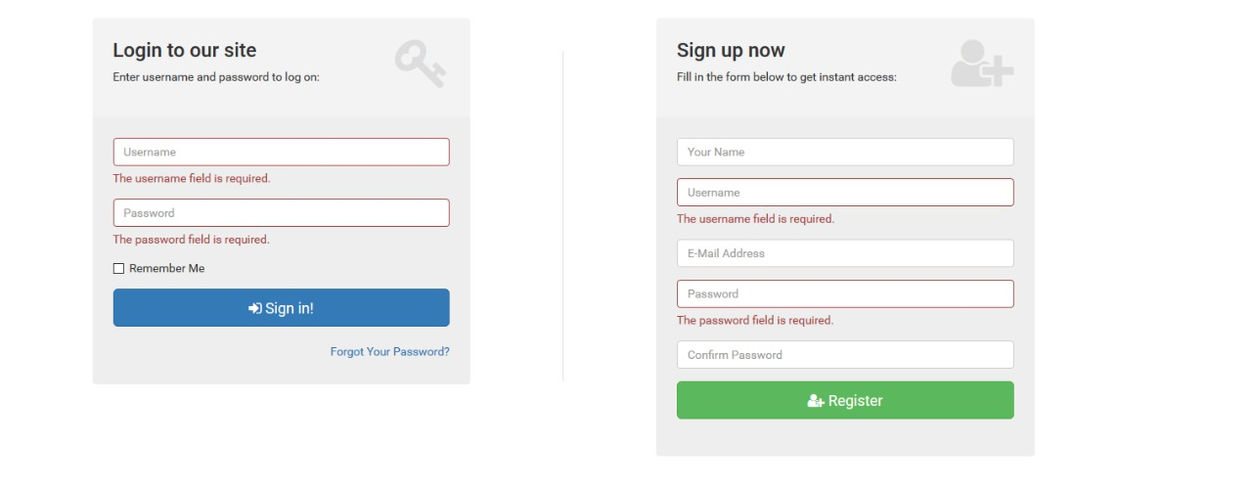

Figure 3: Interface demonstrating login/registration page of web portal

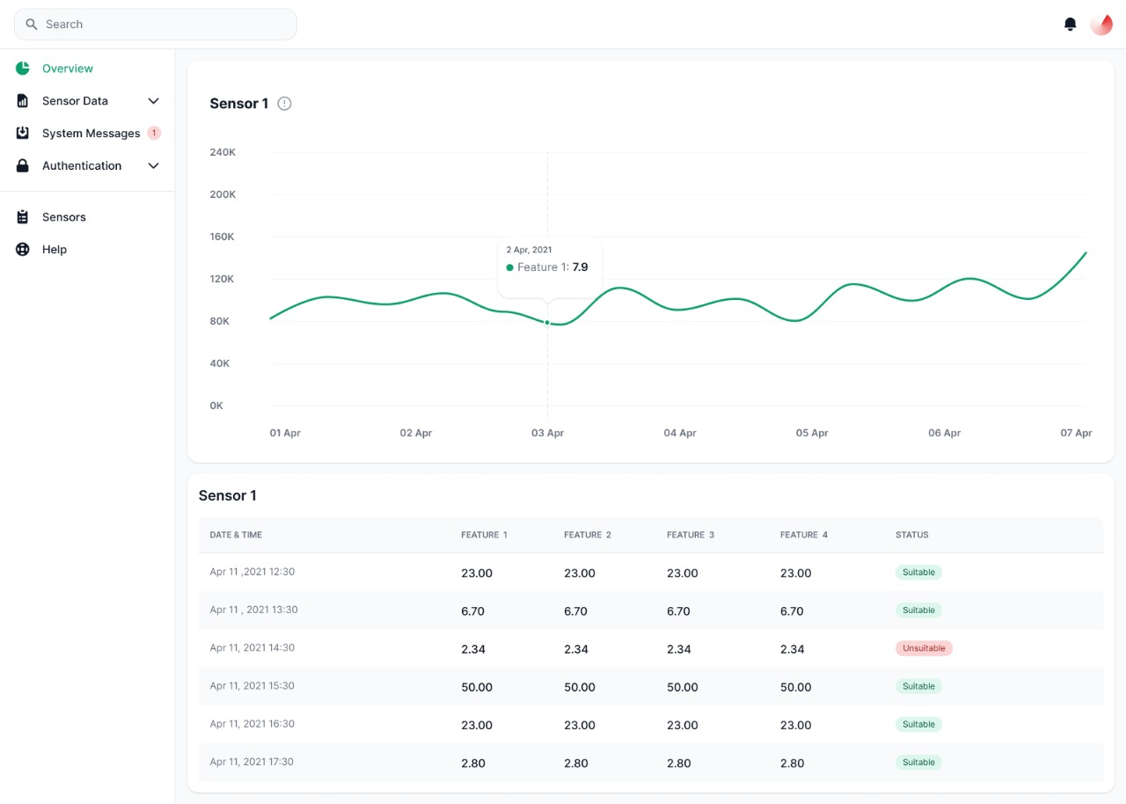

Figure 4: Interface demonstrating visualization page of the web portal

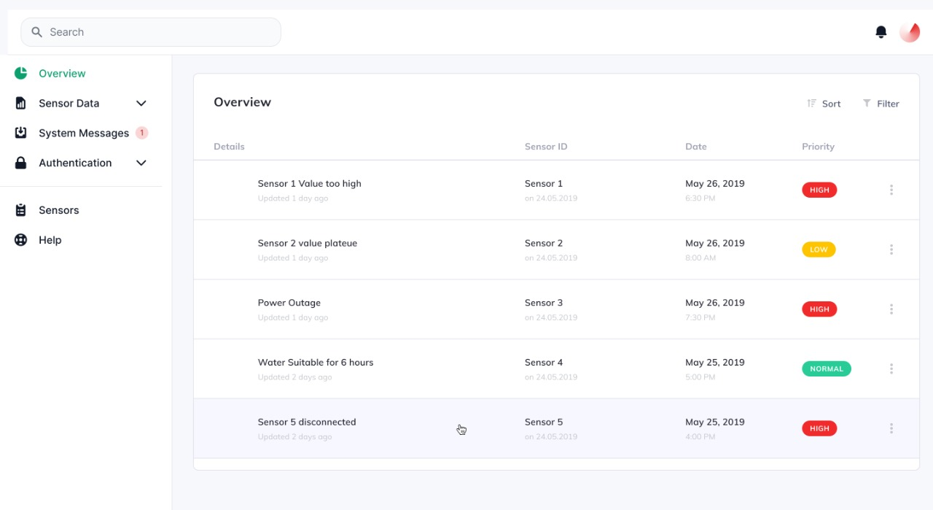

Figure 5: Interface demonstrating the analysis page of the web portal

**2.2.3.2 Hardware Interfaces**

The web portal can be accessed by any system having:

* Access to internet
* A display screen

The hardware aspect of the project includes:

* Variety of sensors for collecting data
* Microprocessor for collection and transmission of data
* WiFi Module for communication with the web portal
* Motor and water pumps to propagate water

**2.2.3.3 Software Interfaces**

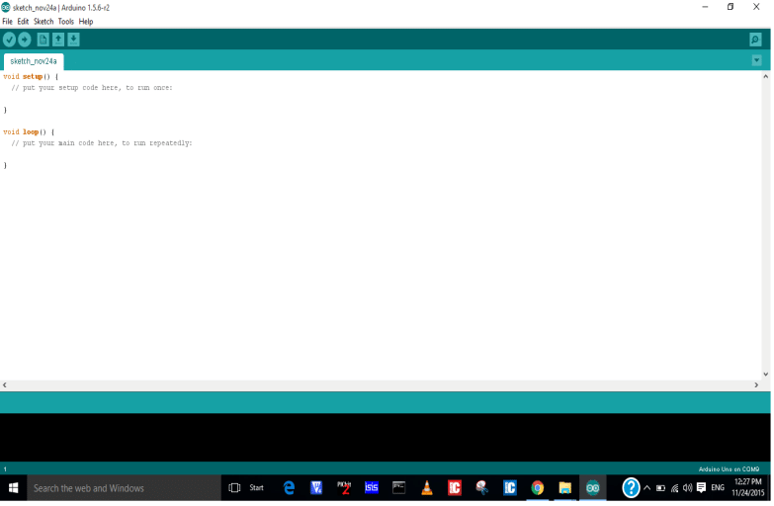

Figure 6: Arduino IDE interface, will be used for monitoring data stream and uploading code to microprocessor

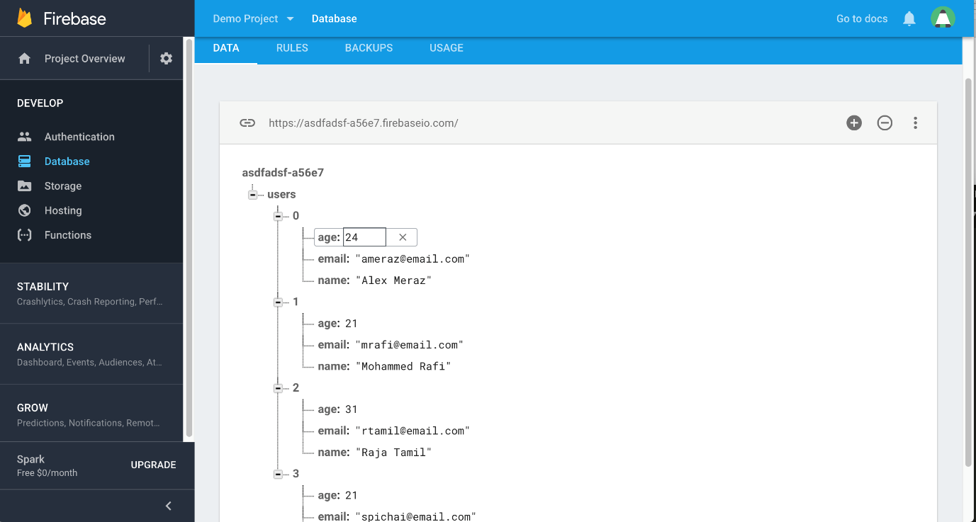

Figure 7: Google firebase used for managing data and uploading data to web portal

**2.2.4 Other Non-functional Requirements**

**2.2.4.1 Performance Requirements**

The system must be interactive and the delays involved must be less. So in every action-response of the system, there are no immediate delays. In case of opening windows forms, of popping error messages and saving the settings or sessions there is delay much below 2 seconds. In case of opening databases, refreshing graphs and analysing data there are no delays and less than 2 seconds are required for performing major operations of the web application.

For the hardware aspect the transmission of data from the sensor should be rigorous and so should be the decision making done by the microprocessor regarding the classification of water.

**2.2.4.2 Safety Requirements**

Information transmission should be securely transmitted to server and microprocessor without any changes in the data.

It is advisable to keep a protective layer over the sensors in order to ensure their optimal functioning.

**2.2.4.3 Security Requirements**

The main security concern is for users account hence proper login mechanism should be used to avoid hacking. The user id registration is way to spam check for increasing the security. Hence, security is provided from unwanted use of the web application.

#### Cost Analysis

#### The proposed solution uses a number of sensors, a microcontroller and LORA module to detect the water quality.

#### The sensors are readily available on e-commerce websites and can be purchased from there.

#### The LORA modules are used to transmit sensor data to microcontroller to calculate water quality. The LORA module clone can be purchased which is a cost effective and reasonable option for the capstone project. The Microcontroller used will be ARDUINO UNO which can be purchased online as well

#### The online dashboard is in form of a software and can be accessed on Windows/MAC OS therefore there is no need to purchase a separate specific hardware. The dashboard can be accessed via the desktop only.

TABLE 5: COST BREAKUP

|  |  |
| --- | --- |
| Items Purchased | Cost |
| Temperature Sensor | Rs. 95 |
| Turbidity Sensor with module | Rs. 745 |
| Liquid PH value Detection Sensor for Arduino | Rs. 1095 |
| Water Flow Sensor | Rs. 749 |
| Arduino UNO | Rs. 585 |
| ESP8266 WiFi Module | Rs. 165 |
| LoRa Module | Rs. 375 |

#### Risk Analysis

#### There are a few risk factors included in the completion of this project. The project requires training of data using machine learning model which requires a certain amount of computational power which can be a risk factor. The device relies on data acquired through the sensors therefore it is important for the sensors to work in a proper manner and any inaccuracy by the sensors can change the result of our findings.

##### 3. Methodology Adopted

3.1 Investigative Techniques

Table 6: Investigative Techniques

|  |  |  |  |
| --- | --- | --- | --- |
| **S.**  **No.** | **Investigative Projects Techniques** | **Investigative Techniques Description** | **Investigative Projects Examples** |
| 1 | Descriptive | Our system is based on speed and simplicity, and aimed at reducing the cost while keeping the functionality the same.  Therefore, having carefully selected  Features are a must.  For this, we explored scientific papers pertaining to water quality in order to see which features will help  Assess water quality.  Moreover, we also checked how these researches handled and automated the collection of data:  1. How their network was made (if any)  2. How they analysed the data, whether it was on site or if data was stored on a database and then analysed on a much more powerful system  3. What algorithms were used to anaslyse the water. | Some of these questions of ours were answered fully, while some left us unsatisfied with the process, which have been talked about more in the previous sections.  The networks usually consisted of a microprocessor on site to which sensor nodes were connected, these collected data and transferred it onto an online database for further processing.  The data was mostly analysed using machine learning methods such as SVM, kNN to classify water, it was not being done on-site. In most cases the data was being collected, uploaded to a computer for analysis using computationally expensive machine learning algorithms like the ones mentioned above. |
| 2 | Comparative | Our project is fundamentally a classification system based on assessing the water quality.  The system will collect data from the water via the help of sensors and then use the collected data to classify the water as suitable for irrigation and farming or unsuitable. This classification will be done on site in order to keep the system independent from the internet. If the water is suitable then it will be pumped to the fields, and if the water is unsuitable then the water will be pumped to a treatment facility or elsewhere.  So, the sooner that the water is classified, the less negative effect it will have on the overall yield of the fields. For example, if the water is classified as unsuitable in three seconds, and the flow of the water is, say, 100 cubic meters per second (100cms) then the fields will still get 300 cubic meters of unsuitable water due to a slower classification algorithm.  Moreover, if the water is suitable and the pump for the treatment facility is turned on beforehand, then 300 cubic meters of suitable water will be sent to the treatment facility, thereby wasting that water.  Finding the optimal machine learning algorithm is thus, imperative, for reducing the overall negative impact of unsuitable water on the fields, as well as reducing the wastage of suitable water.  Thus, for finding the best machine learning algorithm, a combination of Experimental as well as Comparative techniques were used. | Theoretically, k Nearest Neighbours is not a suitable algorithm for our use case as the processing will take long due to constant calculation of Medians and sorting.  Similarly, while pre-trained neural networks can work optimally, they will require a large memory to store weight parameters and activations as the inputs propagate through the network.  Our system uses the Arduino Uno which only has 32k bytes of flash memory.  Support Vector Machines will also require a large calculations, and similarly Random Forest classifiers will require space to store the forest created. The higher the number of trees, the more probabilities to store for majority voting.  By the process of elimination this leaves us with Logistic Regression, Optimized Logistic regression with Stochastic Gradient Descent as well as Decision Tree classifiers. |
| 3 | Experimental | In this technique we used different languages and technologies to see how they would affect the final product.  Beginning with the website, prototype pages were made using React, and for the backend flutter and Django were used.  From these Django was selected for the backend and instead of React, simple javascript has been used for the website as of yet.  Similarly, the classification algorithms were tested with random samples of data. However this was done using python, and more investigation will be done for this. | As stated above, the following algorithms were tested and were fast and required lower memory.  However, right now the memory and time usage has been based on python language.  The second phase of the experiment will be using Cython and storing the code onto the Arduino for calculation, or using full fledged C++ or C for the algorithms. |

3.2. Proposed Solution

The Project focuses on determining quality of water and classifying water as good quality or bad quality for the purpose of irrigation as well as automatically diverting bad-quality water to the treatment pump, before going to fields.

The data of water would be collected through the sensors. The sensors used would collect data regarding:

* Ph value
* SAR
* Temperature and
* Turbidity

The analog pH meter is specially designed for Arduino controllers and has built-in simple, convenient and practical connection and features. It has an LED which works as the Power Indicator, a BNC connector and PH2.0 sensor interface. You can just connect the pH sensor with BNC connector, and plug the PH2.0 interface into any analog input on Arduino controller to read pH value easily.

The SAR value will be specifically calibrated in conjunction with the Electronics (ECE) and

Chemistry (CHE) departments of TIET, wherein the ECE department will be helping in the creation of the sensor, while the CHE department will be helping to analysis samples of water to calibrate the sensor.

The DHT11 is a digital temperature sensor that measures temperature and relative humidity. These sensors contain a chip that does analog to digital conversion and spit out a digital signal with the temperature and humidity. This makes them very easy to use with any microcontroller, including the Arduino.

The turbidity sensor detects water quality by measuring the levels of turbidity. It uses light to detect suspended particles in water by measuring the light transmittance and scattering rate, which changes with the amount of total suspended solids (TSS) in water. As the TTS increases, the liquid turbidity level increases

The sensors used to calculate the pH value, temperature, turbidity etc. are available on various e-commerce platforms for purchasing at a reasonable cost.

The data obtained would be sent to a microcontroller through the help of a LORA module which would transmit data wirelessly through a WAN network with a receiver connected to a microcontroller.

The use of a wireless network is to give the user the freedom to place the sensors wherever the data can be obtained from. Each sensor will be connected to an Arduino which will subsequently be connected to a LORA transmitter. This will constitute a ‘sensor node’.

And each sensor node will transmit data to the main Arduino connected to a LORA receiver as well as the ESP2866 Wi-Fi module.

Once the main Arduino receives the data, then it will be written into the serial monitor of the Arduino uno. From there, the ESP2866 will read the data from the serial monitor and transfer it to the firebase database.

A machine learning model is uploaded on the microcontroller which would determine whether the water quality is suitable or not. The machine learning model would be selected after exploring various models and analyzing their performance based on accuracy. As stated above, time is of the essence and currently Logistic regression, optimized Logistic regression, and Decision tree classifier are in the run to be tested and used.

The data sent onto the Firebase will be displayed and available onto the user dashboard.

As stated before, the classification will be done on site in order to keep the system independent of the internet. This is another reason for the wireless network, since the sensor nodes can be placed at the source of water irrigation, such as a water pump, and the farmer can then place the receiver node near Wi-Fi. It must also be re-iterated that the dashboard is non-essential, our system will work and classify water without connection to the database as well.

Based on the result obtained the water would be directed either to a treatment plant or to the field. This will be done by turning on the respective pump, as well as turning off the other pump.

The raw data obtained will be uploaded on the dashboard where it can be analyzed/visualized. This way the user on logging in can view the data regarding water quality which helps him keep informed.

The webpage would contain the user security features so that the user can login and access data safely. The user would have to enter the login details or else the webpage would not show the data. The user would require to have an internet connection in order to access the webpage.

In this way this add-on feature of webpage will help the user understand the data regarding water better and help him economically

Moreover, while researching for this project, our team has realized that structured data for water analysis using Machine Learning algorithms is not widely available. Hence, we are in the process of adding a reinforcement learning model for which the user will have to add the yield of the crops after every season, and based on those results, changes to the classification algorithm can be made.

This data can then, be made available for anyone wishing to use it later for their own interests under the MIT License. However, this is still a hypothetical.

**3.3Work Breakdown Structure**

Figure 8: Work Breakdown Structure

The work is divided into four sections, Hardware, Data collection, Classification Model and Web Interface Creation.

Out of these four, the hardware and Web interface have already been prototyped.

Initially the hardware has been tested using a single ultrasonic sensor in order to check the connection between the Firebase database and ESP2866. The data is collected by the sensor and written onto the Serial monitor. From there, the ESP2866 reads the data from the Serial monitor, and uploads it onto the Firebase database. This is done using Arduino libraries.

The database values are then fetched using python libraries and sent to Django views to be used to create graphs.

A landing page for the web interface has also been created.

The following Gantt chart is based on the above Work breakdown structure.

Figure 9: Gantt Chart

It can be seen from the Gantt chart that we are well ahead of schedule with only wireless transmission of sensor data, and classifying the water based on sensor data requiring work.

**3.4 Tools and Technology**

Table 7: Tools and Technology

|  |  |
| --- | --- |
| Tool used | Reason |
| Esp2866 wifi module | Used to connect to Wi-Fi and upload sensor data onto the Firebase database |
| Arduino uno | Used for making the sensor and receiver nodes. The classification algorithm will also be uploaded onto the Arduino. |
| Firebase - NoSQL | Used to store user authentication data as well as sensor data |
| Sensors – all | Used to collect data from the water for analysis |
| Python | Used to compare various machine learning classification algorithms and used for the backend of the Website. |
| Django | Python Web Development framework used for the backend of the website. |
| Jquery | Used for AJAX requests to update the graphs in real time without reloading the website. |
| HTML | Used for the basic skeleton of the website |
| CSS | Used to stylize the website and dashboard |
| JavaScript | Used to provide functionality to the dashboard |
| Charts.js | Javascript library used for all the graphs |
| Figma | Online tool used to create the front end and prototypes of the website. |

**4. Design Specifications**

* 1. **System Architecture**

Figure 10: MVC architecture-Django

Model View Controller diagram represents the project in three parts:

* Model(includes sensor data and user id)
* View(includes the landing page, analysis page and graphic page of the online dashboard)
* Controller(includes url_mappings and change-pages which acts as interface between view and model components)
  1. **Design Level Diagrams**

Figure 11 :Class Diagram

The above figure (figure no. 9) shows the 4 classes of our project and the various attributes and operations associated with it. The arrows joining two classes denote the association between them.

Figure 12: ER Diagram

Entities are denoted by a rectangle in the given figure 10. The 4 entities of the entity set are User, Sensor, Classifier and DashBoard. The User entity has two single valued attributes user_id which stores the user id and wifi_credentials which stores the wifi credentials on which user is logged in. Similarly classifier has two single valued attributes model and classification_id. The Sensor entity has a single valued attribute sensor_id and a multi valued attribute sensor_data.

Figure 13: DFD level 0

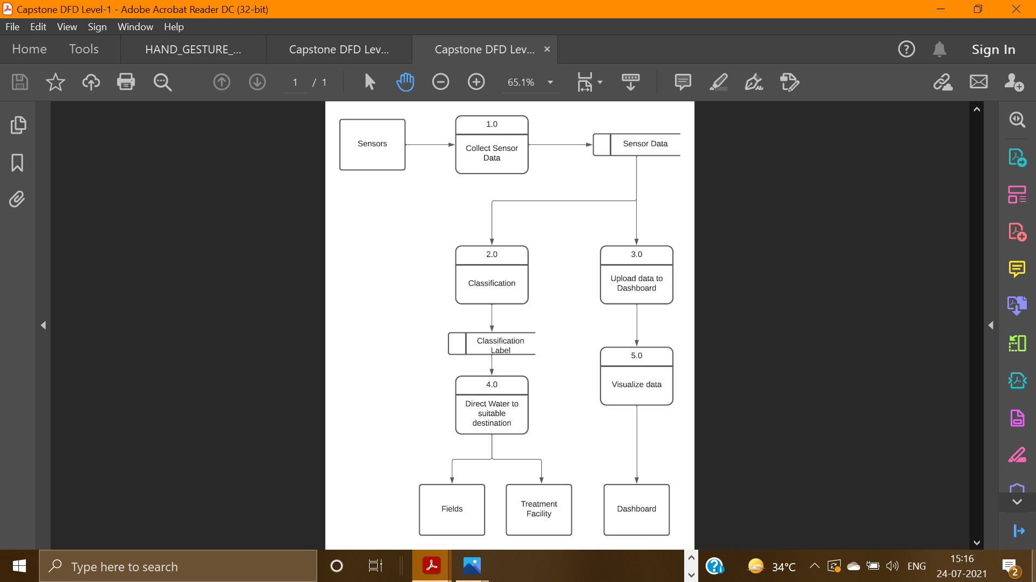

Figure 14: DFD Level 1

Figure 15: DFD Level 2

The Data Flow Diagram is shown in the form of three levels. The Level 0 is called context diagram. The data flow diagrams show the flow of data from one source to other. The starting source is the sensors which collects the sensor data which then passed through various processes and ultimately reaches the dashboard/treatment facility/fields

* 1. **User Interface Diagrams**

Figure 16: Landing Page of Web Portal

Figure 17: Interface demonstrating the analysis page of the web portal

Figure 18: Interface demonstrating visualization page of the web portal

* 1. **Snapshots of Working Prototype**

Figure 19: Landing Page

The landing page consists of photos, diagrams and texts showing people how our system works and how it can be used to increase crop yield and reduce water.

Figure 20 : Wireframe Page

The images above are our wireframed page, which do not contain any information as of yet.

Figure 21: post login webpage

On logging in, the user will be greeted with this page which tabulates all the information provided by the sensors. Currently the table has not been implemented here but it can be seen in our User interfaces in prior sections.

Figure 22: Sensor data Graph Page

On selecting a specific sensor, the user will be met with a graph like this which plots the sensor data as a time series graph.

Figure 23: Microcontroller

The microcontroller and sensor connected to gather and upload data

##### 5.Conclusions and Future Scope

5.1 Work Accomplished

According to the approved objectives, the following tasks has been accomplished

1. To integrate different sensors and Wi-Fi module with an IoT device and build a cost-effective hardware setup

Here, the basic concept of writing and reading data to a WiFi module and storing it onto our database has been achieved. This will help us further when we transition from a development prototype to finished product.

2. To develop an interactive web dashboard to tabulate live readings from the sensors for the user.

The major skeleton of the dashboard has been created, with only some pages remaining such as user settings etc. However, the template of these have been stored for reuse. The connection between the Firebase database and the website has also been achieved. With the use of Django framework, the website is running without any issue. Similarly, the use of Charts.js has proved integral for creating the graphs that are visualized in front of the user for further analysis.

3. To process data from different sensors like SAR sensor, pH sensor humidity sensor etc. calibrate the readings and send it to web portal using the IoT device.

And lastly, while the task below has not been accomplished with the sensors mentioned, the fundamental logic behind it has been understood and implemented, albeit with different sensors. The only task remaining in the above objective is the calibration of the actual sensors for the finished product.

5.2 Conclusions

In the previous panel meeting we had very well highlighted the dire need of a water quality assistant by the farmers so as to prevent their crops from getting damaged.

We conducted surveys to conclude the need for our system to be implemented and found that there is a big fat room for our project to gloom as a remarkable product in the outside world as well.

We gathered the hardware components and built a functioning prototype for our setup. Further we designed and developed a functioning web portal connected to a database and established the data transmission from the microprocessor to the database API and from the database to the dashboard of the web portal. We further have started exploring different classification algorithms for the segregation of water and have developed an interesting palette of available algorithms which gave accurate results on the dummy dataset and fit within the constraints of hardware memory available.

5.3 Environmental (/ Economic/ Social) Benefits

The proposed solution of our team collects and analyze data of water and determines whether the water is fit for irrigation or not. In this way we can help the farmers save their crops from being destroyed due to unfit water. In addition to this our solution also redirects unfit water to a treatment plant so that it can be treated and then utilized in a suitable manner. In this way we are able to save water and make judicious use of it. This helps conserve our natural resource which positively impacts our environment. It also helps the farmers in an economic way as it saves their crops from being destroyed by unfit water. Another benefit of using our product is the provision of constant, structured and secure data regarding the water that is used by the farmers. This data can be used further to implement better systems as technology improves, and it can also be used to analyse any long-term issues that may be costing farmers a fortune. For example, if the water begins to turn unsuitable for a few months, then it can be analysed using our system and dashboard. In this way the crops of our country are saved from being destroyed which ultimately helps increase the nation’s agricultural productivity leaving a positive impact on the social and economic structure of our country.

5.4 Future Work Plan

#### As of now we have devised the hardware aspect of our project and have developed basic skeleton structure of our web portal.

#### Our next target is to accumulate real time readings from irrigation water and organize them into a moderate dataset. Experimentation of different classification algorithms for the segregation of water is currently underway and the next stage would be to find its metrics on real time readings.

#### We plan on creating a secure and data analysis centric web portal for our project. We have already decided on the design of the web pages and started work on user identification and authentication.

#### Lastly work is to be done on the analysis and visualization techniques for the web pages of our portal so as to make them user friendly and responsive.

#### We are in synchronization with our work plan and hope to complete the system by the end of October.

**REFERENCES**

[1] D. W. R.S. Ayers, “WATER QUALITY EVALUATION: Food and Agriculture Organization of the United Nations,” 1994. [Online]. Available: <http://www.fao.org/3/t0234e/T0234E00.htm#TOC>.

[2] Sophia Karastogianni, Stella T. Girousi. pH: Principles and Measurement. December 2016. Available <https://www.researchgate.net/publication/301702485_pH_Principles_and_Measurement>

[3] E. J. Williamson, Frank Wiersma ,L. O. Fine. A Study of the Sodium Adsorption Ratio and Residual Sodium Carbonate Concepts of Irrigation Waters as They Affect Exchangeable Sodium of Soil Under Semiarid Conditions. Available

[https://acsess.onlinelibrary.wiley.com/doi/abs/10.2136/sssaj1959.0361599500230004 0011](https://acsess.onlinelibrary.wiley.com/doi/abs/10.2136/sssaj1959.0361599500230004%200011)x

[4] IEEE Internet of Things Journal. Issue 6, March15,-2021.Available <https://ieeexplore.ieee.org/xpl/mostRecentIssue.jsp?punumber=6488907>

[5] S. Wang, Z. Zhang, Z. Ye, X. Wang, X. Lin, S. Chen, Application of environmental internet of things on water quality management of urban scenic river. Int. J. Sustain. Dev. World Ecology.

20(3), 216–222(2013).

<https://doi.org/10.1080/13504509.2013.785040>

[6] U. Shafi, R. Mumtaz, H. Anwar, A.M.Qamar, H. Khurshid, Surface water pollution detection using internet of things, in 2018 15th International Conference on Smart Cities: Improving Quality of Life Using ICT & IoT (HONET-ICT), Islamabad,

Pakistan, 8–10h Oct 2018). IEEE

[7] K. Saravanan, E. Anusuya, R. Kumar, Real-time water quality monitoring using Internet of Things in SCADA. Environ. Monit. Assess. 190(9), 556 (2018). https://doi.org/10.1007/s10 661-018-6914-x

[8] IEEE Wireless Communications. Issue 1, February-2021.Available <https://ieeexplore.ieee.org/xpl/mostRecentIssue.jsp?punumber=77422>

[9] Ismail Butun, Nuno Pereira, Mikael Gidlund. Analysis of LoRaWAN v1.1 security: research paper (2018). Available [https://www.researchgate.net/publication/325493576_Analysis_of_LoRaWAN_v11_s ecurity_research_paper](https://www.researchgate.net/publication/325493576_Analysis_of_LoRaWAN_v11_security_research_paper)

[10] P. Liu, J. Wang, A.K. Sangaiah, Y. Xie, X. Yin, Analysis and prediction of water quality using LSTM deep neural networks in IoT environment. Sustainability 11(7), 2058 (2019). https:// doi.org/10.3390/su11072058/

[11] Makki, Z.F., Zuhaira, A.A., Al-Jubouri, S.M. *et al.* GIS-based assessment of groundwater quality for drinking and irrigation purposes in central Iraq. *Environ Monit Assess* **193,**107 (2021).

<https://doi.org/10.1007/s10661-021-08858-w>

**APPENDIX B: Plagiarism Report**

About 14% of this document consists of text similar to text found in161sources. The largest marking is 257 words long and is 83% similar to its primary source.

